Intermediate Web Dev - Final Project Overview



**Estimated time needed: 2 hours**

**You will have the opportunity to take your Intermediate Web Dev skills and put them into action in a project that combines these technologies into a single web application. You will be provided with a boilerplate code for an Interest Rate Calculator app.**

**Then using the skills you learned in this course, you will improve its SEO, improve the load time by using Webpack, and debug any issues using Chrome DevTools.**

# Objectives:

1. **Learn how to practice debugging in Chrome, using breakpoints, watch and errors in Console**
2. **Use Jasmine to test your business logic**
3. **Improve SEO for better reach and visibility on Search Engines**
4. **Using Webpack to create for assets**

# Project Breakdown

**Part A: Fix the existing errors**

1. **Clone the repository and initialize your development environment**
2. **Fix the errors in HTML and JavaScript**

**Part B: Make it testable**

1. **Use Jasmine to test your Calculate function**
2. **Write your test specs**
3. **Fix your business logic**

**Part C: Introduce Webpack and improve SEO**

1. **Introduce Webpack to make and package your distributables**
2. **Improve SEO of your Calculator app**

# Review Criteria – 10 marks total

1. **Get favicon to display in your browser tab 1 mark**
2. **Get CSS working and take a screenshot of the same 1 mark**
3. **Missing JavaScript reference error seen in Chrome DevTools and take a screenshot of the same 1 mark**
4. **Pause on Exception on the first line inside the calculate function and take a screenshot of the same 1 mark**
5. **Pause on the line where it calls .toFixed on p and take a screenshot of the same 1 mark**
6. **Install Jasmine for testing and take a screenshot of running it (without any actual tests) 1 mark**
7. **Two tests successfully run in Jasmine and take a screenshot of the same 1 mark**
8. **dist directory showing favicon.ico, index.html, main.js, and style.css and take a screenshot of the same 1 mark**
9. **Final output showing correct calculation along with CSS and side by side Chrome DevTools showing Source with five highlighted sections as shown below 2 marks**

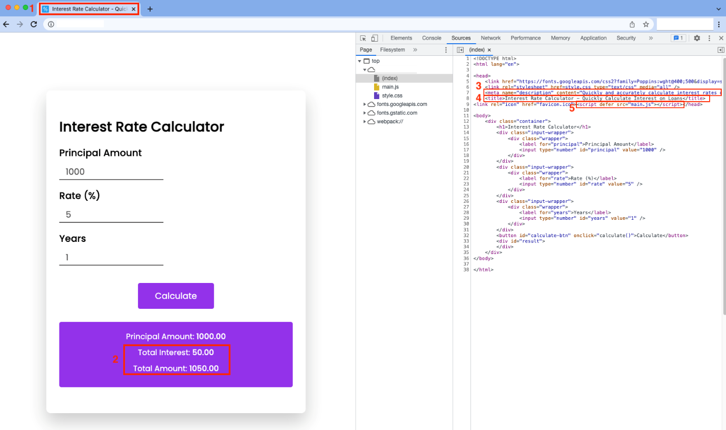

***The images submitted should not be sample screenshots.***

# Final Output

**The final output should look like the following:**

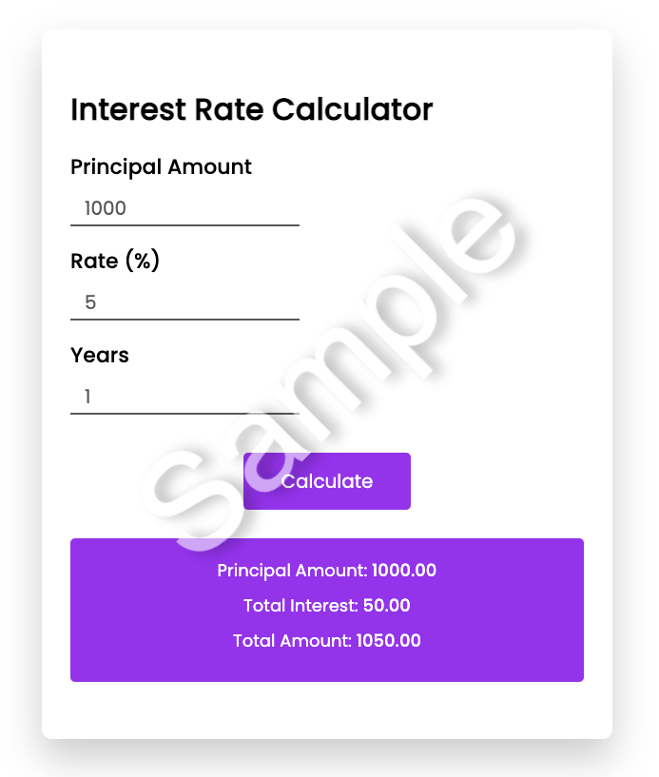

**Author(s)**

[**Muhammad Yahya**](https://www.linkedin.com/in/1muhammadyahya/)

